Chapter 2 Question 5 and 14 - Michael Streyle

##   
## Call:  
## lm(formula = ServiceMinutes ~ NumCopiers)  
##   
## Coefficients:  
## (Intercept) NumCopiers   
## -0.5802 15.0352

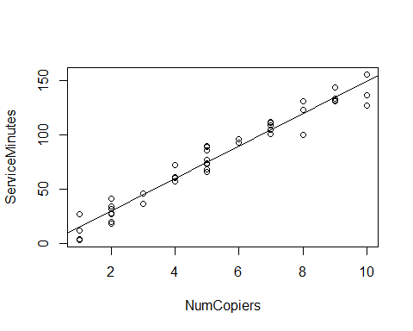

##   
## CONFIDENCE LIMITS FOR INTERCEPT AND SLOPE:

## 5 % 95 %  
## (Intercept) -5.29378 4.133467  
## NumCopiers 14.22314 15.847352

## [1] 1.681071

## [1] 0.01891548

##   
## HYPOTHESIS TESTS FOR INTERCEPT AND SLOPE:

## Estimate Std. Error t value Pr(>|t|)  
## (Intercept) -0.5801567 2.8039411 -0.2069076 8.370587e-01  
## NumCopiers 15.0352480 0.4830872 31.1232581 4.009032e-31

##   
## CONFIDENCE INTERVAL FOR A MEAN RESPONSE at NumCopiers = 6:

## fit lwr upr  
## 1 89.63133 87.28387 91.9788

##   
## PREDICTION INTERVAL FOR AN INDIVIDUAL RESPONSE at NumCopiers = 6:

## fit lwr upr  
## 1 89.63133 74.46433 104.7983

##   
## PREDICTION INTERVAL FOR AN EXPECTED RESPONSE, PER COPIER:

## fit lwr upr  
## 1 14.93856 14.54731 15.3298

##   
## WORKING-HOTELLING CONFIDENCE BAND (LIMITS) at NumCopiers = 6

## fit lower upper  
## 1 89.63133 86.55263 92.71003

##   
## ANOVA TABLE:

## Analysis of Variance Table  
##   
## Response: ServiceMinutes  
## Df Sum Sq Mean Sq F value Pr(>F)   
## NumCopiers 1 76960 76960 968.66 < 2.2e-16 ***  
## Residuals 43 3416 79   
## ---  
## Signif. codes: 0 '***' 0.001 '**' 0.01 '*' 0.05 '.' 0.1 ' ' 1

## DF Sum Sq  
## Corr. Total 44 80376.8

##   
## R SQUARED:

## [1] 0.9574955

##   
## CORRELATION COEFFICIENT:

## [1] 0.978517